Project Planning Phase
Project Planning Template (Product Backlog, Sprint Planning, Stories, Story points)

Date | 30 September 2026
Team ID | SWTID-2026-4912
Project Name | AI WeatherWise
Maximum Marks | 5 Marks

Product Backlog, Sprint Schedule, and Estimation (4 Marks)
Use the below template to create product backlog and sprint schedule
Sprint | Functional Requirement (Epic) | User Story Number | User Story / Task | Story Points | Priority | Team Members
Sprint-1 | Registration | USN-1 | As a user, I can register for the application by entering my name, email, password, and confirming my password. | 3 | High | Team Member 1
Sprint-1 | Registration | USN-2 | As a user, I will receive a confirmation email once I have registered for the application. | 2 | High | Team Member 2
Sprint-1 | Login | USN-3 | As a user, I can log into the application by entering my email & password. | 2 | High | Team Member 3
Sprint-1 | Weather Search | USN-4 | As a user, I can search the weather of any city by typing its name. | 3 | High | Team Member 4
Sprint-1 | Weather Search | USN-5 | As a mobile user, I can let the app detect my current location automatically. | 2 | Medium | Team Member 1
Sprint-1 | Current Weather Dashboard | USN-6 | As a user, I can view the current temperature, humidity, wind speed, pressure and visibility on the dashboard. | 5 | High | Team Member 2
Sprint-1 | Current Weather Dashboard | USN-7 | As a user, I can switch between Celsius and Fahrenheit. | 3 | Medium | Team Member 3
Sprint-2 | Forecast | USN-8 | As a user, I can view the hourly forecast for the next 24 hours. | 5 | High | Team Member 4
Sprint-2 | Forecast | USN-9 | As a user, I can view the 7-day forecast. | 5 | High | Team Member 1
Sprint-2 | Forecast | USN-10 | As a user, I can see the Air Quality Index (AQI) of my city. | 3 | Medium | Team Member 2
Sprint-2 | Weather API Integration | USN-11 | As a user, I get weather results quickly because recent weather data is cached by the system. | 5 | High | Team Member 3
Sprint-2 | Favourite Cities | USN-12 | As a user, I can save my favourite cities. | 2 | Medium | Team Member 4
Sprint-3 | AI Insights | USN-13 | As a user, I can read an AI-generated plain-language summary of today's weather. | 5 | High | Team Member 1
Sprint-3 | AI Insights | USN-14 | As a user, I can see the rain probability predicted by AI for the next few hours. | 8 | High | Team Member 2
Sprint-3 | AI Insights | USN-15 | As a user, I receive personalised clothing and travel tips based on the weather. | 4 | Medium | Team Member 3
Sprint-3 | Weather History | USN-16 | As a user, I can view a trend chart of past weather data of my city. | 3 | Low | Team Member 4
Sprint-4 | Alerts & Notifications | USN-17 | As a user, I receive email alerts for severe weather such as heavy rain, storm or heat wave. | 5 | High | Team Member 1
Sprint-4 | Alerts & Notifications | USN-18 | As a mobile user, I receive a daily morning weather briefing. | 3 | Medium | Team Member 2
Sprint-4 | Administration | USN-19 | As an administrator, I can view registered users and API usage logs. | 3 | Low | Team Member 3
Sprint-4 | User Interface | USN-20 | As a user, I can use dark mode and a layout that fits my phone, tablet and desktop. | 3 | Medium | Team Member 4
Sprint-4 | Testing & Deployment | USN-21 | As a user, I can access a stable, tested application online at any time. | 6 | High | Team Member 1

Project Tracker, Velocity & Burndown Chart: (4 Marks)
Sprint | Total Story Points | Duration | Sprint Start Date | Sprint End Date (Planned) | Story Points Completed (as on Planned End Date) | Sprint Release Date (Actual)
Sprint-1 | 20 | 6 Days | 05 Oct 2026 | 10 Oct 2026
Sprint-2 | 20 | 6 Days | 12 Oct 2026 | 17 Oct 2026
Sprint-3 | 20 | 6 Days | 19 Oct 2026 | 24 Oct 2026
Sprint-4 | 20 | 6 Days | 26 Oct 2026 | 31 Oct 2026

Velocity:
Imagine we have a 10-day sprint duration, and the velocity of the team is 20 (points per sprint). Let’s calculate the team’s average velocity (AV) per iteration unit (story points per day)
AI WeatherWise: sprint duration = 6 days and team velocity = 20 story points per sprint (total 80 story points in 4 sprints). Average velocity (AV) per day = 20 / 6 = 3.33 story points per day.


Burndown Chart:
A burn down chart is a graphical representation of work left to do versus time. It is often used in agile software development methodologies such as Scrum. However, burn down charts can be applied to any project containing measurable progress over time.
Planned burndown chart for AI WeatherWise (80 story points over 24 project days):
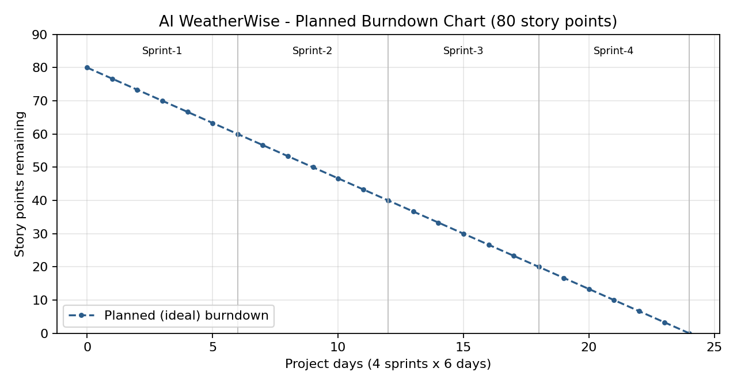

https://www.visual-paradigm.com/scrum/scrum-burndown-chart/
https://www.atlassian.com/agile/tutorials/burndown-charts

Reference:
https://www.atlassian.com/agile/project-management
https://www.atlassian.com/agile/tutorials/how-to-do-scrum-with-jira-software
https://www.atlassian.com/agile/tutorials/epics
https://www.atlassian.com/agile/tutorials/sprints
https://www.atlassian.com/agile/project-management/estimation
https://www.atlassian.com/agile/tutorials/burndown-charts

